CHAPTER 3: Evolution
Worksheet 3.1

Struggling to survive
Student: Class:
1. Define the term ‘adaptation’.

2. Explain how each of the following examples are adaptations for survival.
(a) Desert marsupials excrete small quantities of very concentrated urine.

(b) Polar bears have a thick fur coat.

3. Blackberries and cane toads are introduced species in Australia.
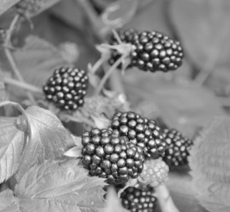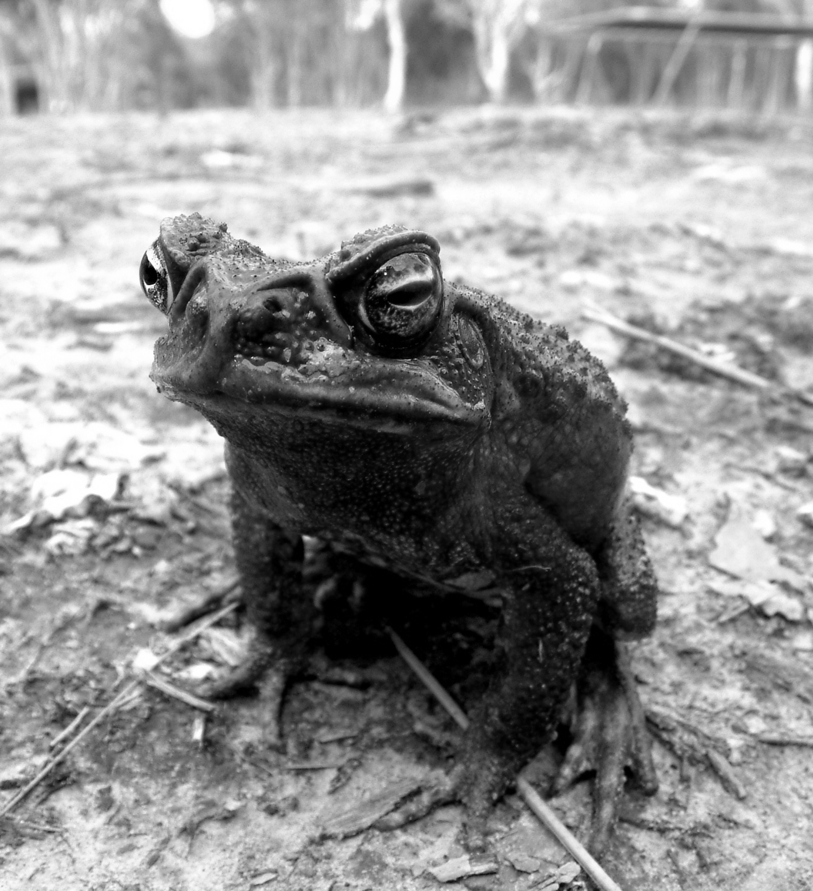
Photos:
Blackberries: digifuture/123RF
Cane toad: Hypervision Creative/Shutterstock.com
(a) Blackberries were introduced to Australia in the 1800s and have spread across the landscape and taken over various habitats. Explain why this plant has successfully outcompeted native species.

CHAPTER 3: Evolution
Worksheet 3.1

Page 2

(b) Cane toads were introduced into Queensland to control sugarcane pests. The toad in turn has become a pest and has spread into NSW and the Northern Territory. Explain why the cane toad has been able to invade large areas of land.

4. The Asiatic black bear constructs beds and platforms in trees and eats nuts, fruits and small animals.
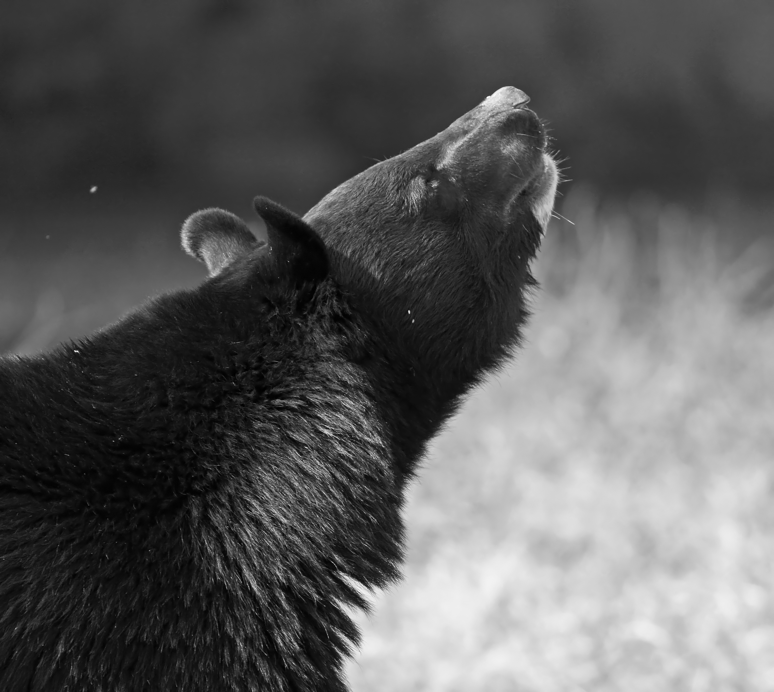
Photo: wildlywise / Shutterstock.com
Describe structural adaptations that the Asiatic bear has in order to survive in its habitat.

